Final Project Report
Class – Final Report

NOMADS

Ammad, Saad, Mashaal & Daniyal

A Report submitted in part fulfilment of the Semester Final Project of
Micro Processor and Micro Controller Based Design
Instructor: Dr.Taimoor Zahid

Department of Computer Engineering
NUST, CEME

Declaration
This report has been prepared based on my own work. Where other published and unpublished source materials have been used, these have been acknowledged.

Word Count:

Group Members:
Ammad Ali, Saad Rasheed, Mashaal Ibne Masha Allah & Daniyal Zahid | 2023

Date of Submission: 18 January, 202

Table of Contents
Abstract 4
Chapter 1: Introduction 5
1.1 What is Data Encryption? 5
1.2 Importance of Data Encryption 5
Chapter 2: Common Encryption Problems 7
2.1 Data Discovery 7
2.2 Key Management: Cloud or On-Premises 7
2.3 Querying Encrypted Data 8
2.4 Performance Overhead 8
2.5 Encryption Algorithm and Key Length 8
2.6 Challenges of Program Management 8
Chapter 3: Solution 10
3.1 Flow Chart Illustration For GUI 11
Chapter 4: Testing Phase of Console Application 12
4.1 Testing Encryption Using File Handling 12
4.2 Testing Decryption Using File Handling 13
4.3 String Message Encryption & Decryption. 15
4.4 Program Functionality 16
Chapter 5: Designing the GUI Algorithm 18
5.1 Encryption 18
5.2 Decryption 18
Chapter 6: GUI 19
6.1 Sign In Form 19
6.2 Main Menu 21
6.3 Encryption (Free User) 21
6.4 Encryption 22
6.5 Decryption 24
Chapter 7: Limitations 26
Chapter 8: Conclusion & Future Work 27

Abstract

There has been an ongoing effort to push cars away from their mechanical features ever since drive-by-wire technology (DBW) emerged. The deployment of autonomous vehicles, but with the worry to prevent collision with objects, is the most significant possibility of this feat. Avoiding collisions is a critical issue for politicians as well as the transportation and logistics sector.

Introduction
Encryption is the process of converting a readable message into an unreadable form in order to prevent unauthorized parties from reading it. The process of converting an encrypted message back to its original (readable) format is known as decryption. The plaintext message is the original message.

What is Data Encryption?
Data encryption is a means of protecting data confidentially by converting it to ciphertext, which can only be decrypted using a unique decryption key generated at the time of encryption or before it.
Data encryption converts data into a different form (code) that only those with a secret key (formally known as a decryption key) or password can access. Data that has not been encrypted is known as plaintext, while data that has been encrypted is known as ciphertext. In today's business world, encryption is one of the most widely used and successful data protection technologies.
Encryption is an essential tool for preserving data integrity, and its significance cannot be overstated. At some point, almost everything on the internet has been encrypted.

Importance of Data Encryption
Encryption's importance cannot be overstated in any way. Even if your data is stored in a standard infrastructure, it is still vulnerable to hacking. There is always the possibility that data will be compromised, but data encryption will make your information much more secure.
Consider it in this light for a moment. Encrypting your data before sending it out will keep it safe if it is stored in a secure system. Sanctioned systems do not offer the same level of security.
So, how do you envision this playing out in real life? Consider the case of a data user who has access to sensitive information while at work. The information can be put on a portable disc and moved wherever the user wants without any encryption. If the encryptions are set up ahead of time, the user can still copy the information, but it will be incomprehensible when they try to view it elsewhere. These are the advantages of data encryption that demonstrate its true worth.
Data Encryption Types:
- Encryption with Symmetric Keys
- Asymmetric Encryption
Encryption is commonly used with either a symmetric key or an asymmetric key.

Symmetric Key Encryption:
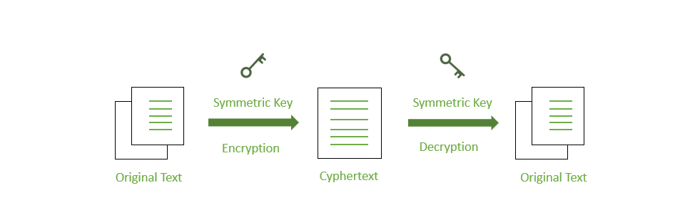
Asymmetric Key Encryption:
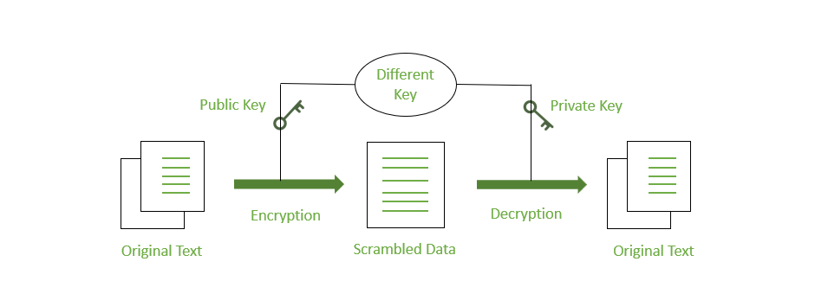

Common Encryption Problems
Data protection is now one of the most important, if not the most important, priority for organisations. With data breaches at an all-time high and new regulations like GDPR and others taking effect, organisations are now focusing on Data Centric Security. As a result, encryption is one of the oldest and most effective technology solutions for enabling organisations to achieve Data Centric Security.
While encryption has been used for centuries, its application is determined by the context of the information being processed as well as the relevant business requirement. As a result, while it may appear simple, encryption has its own set of challenges that must be addressed when designing an encryption solution. These difficulties are well understood by Encryption Consulting.
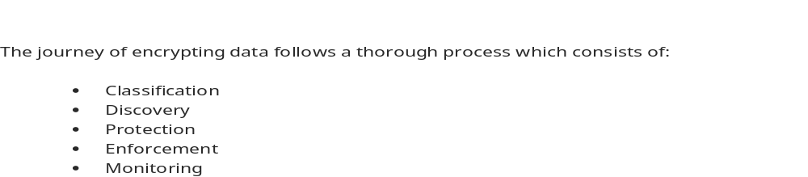

Data Discovery
The first and foremost action for an organization is to locate their sensitive and critical data that requires Encryption which is achieved through means of data discovery and assessment.
Manual Approach
- Discussing with business stakeholders and Data custodians
Tool Based
- Selecting and deploying Data discovery tools for structured, unstructured and semi-structured data stores

Key Management: Cloud or On-Premises
Key management is one of the most critical component for Encryption. It is very important to carefully identify and design best approach suited for your needs
Key Security
- Ensuring Secure keys with constant protection
- Not allowing access of keys to cloud administrators

Controlling keys as the Customer
- If a customer deletes its key, then data will be removed as well
- Maintaining on-premise control of key

Confinement of Key
- Utmost dedication to the key management platform
- Never allowing key swaps

Key Rotation
- Avoid over-use of key which permits vulnerability
- Re-keying data with a new key to create a new key

Querying Encrypted Data
It is frequently necessary to search and index encrypted data stored on-premises or in the cloud. This is a major concern for organisations because it may necessitate frequently decrypting data, increasing the possibility of a hacker gaining access to decrypted data. Furthermore, frequent decryption can increase the demand for system resources and time.

Performance Overhead
Encryption causes a performance overhead whenever data is encrypted. The amount of data encrypted may cause system slowdown.

Encryption Algorithm and Key Length
Another critical aspect of encryption is the choice of encryption algorithm and key length. While choosing a longer key length can improve security and reduce the risk of key compromise, it can have a negative impact on performance because longer keys consume more resources and time. Thus, a thorough understanding of throughput and business requirements should be considered when selecting an encryption algorithm and key length.

Challenges of Program Management
When deciding which type of encryption is best for your organisation, consider the following challenges with encryption programme management:

Planning
- Meeting established requirements and regulations
- Examine the available products/vendors
- Product/vendor Confirmation
Building
- Creating and fine-tuning a safe environment
- Make a plan for system
Integration
- Create Formal Policies
- Format Data
- Perform Performance
- Testing Launch Application
Encryption Consulting can assist our customers in planning and designing the best Encryption solution for securing their data, regardless of where it is stored, without sacrificing business performance or user experience.

Solution
Symmetric key cryptography is any cryptographic algorithm that is based on a shared key that is used to encrypt or decrypt text/cyphertext, in contrast to asymmetric key cryptography, where the encryption and decryption keys are different.
Symmetric encryption is generally more efficient than asymmetric encryption and therefore preferred when large amounts of data need to be exchanged.
Establishing the shared key is difficult using only symmetric encryption algorithms, so in many cases, asymmetric encryption is used to establish the shared key between two parties.
Examples of symmetric key cryptography include AES, DES, and 3DES. Key exchange protocols used to establish a shared encryption key include Diffie-Hellman (DH), elliptic curve (EC) and RSA.
Symmetric cryptography relies on one shared key that both parties know and can use to encrypt or decrypt data.

Symmetric key encryption uses one the following encryption types:
1) Stream ciphers: encrypt the digits (typically bytes), or letters (in substitution ciphers) of a message one at a time
2) Block ciphers: encrypts a number of bits as a single unit, adding the plaintext so that it is a multiple of the block size. Blocks of 64 bits were commonly used. The Advanced Encryption Standard (AES) algorithm approved by NIST in December 2001, and the GCM block cipher mode of operation use 128-bit blocks.

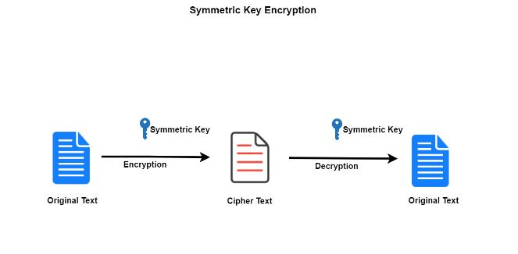
An illustration of how the program is working for us.

Flow Chart Illustration For GUI

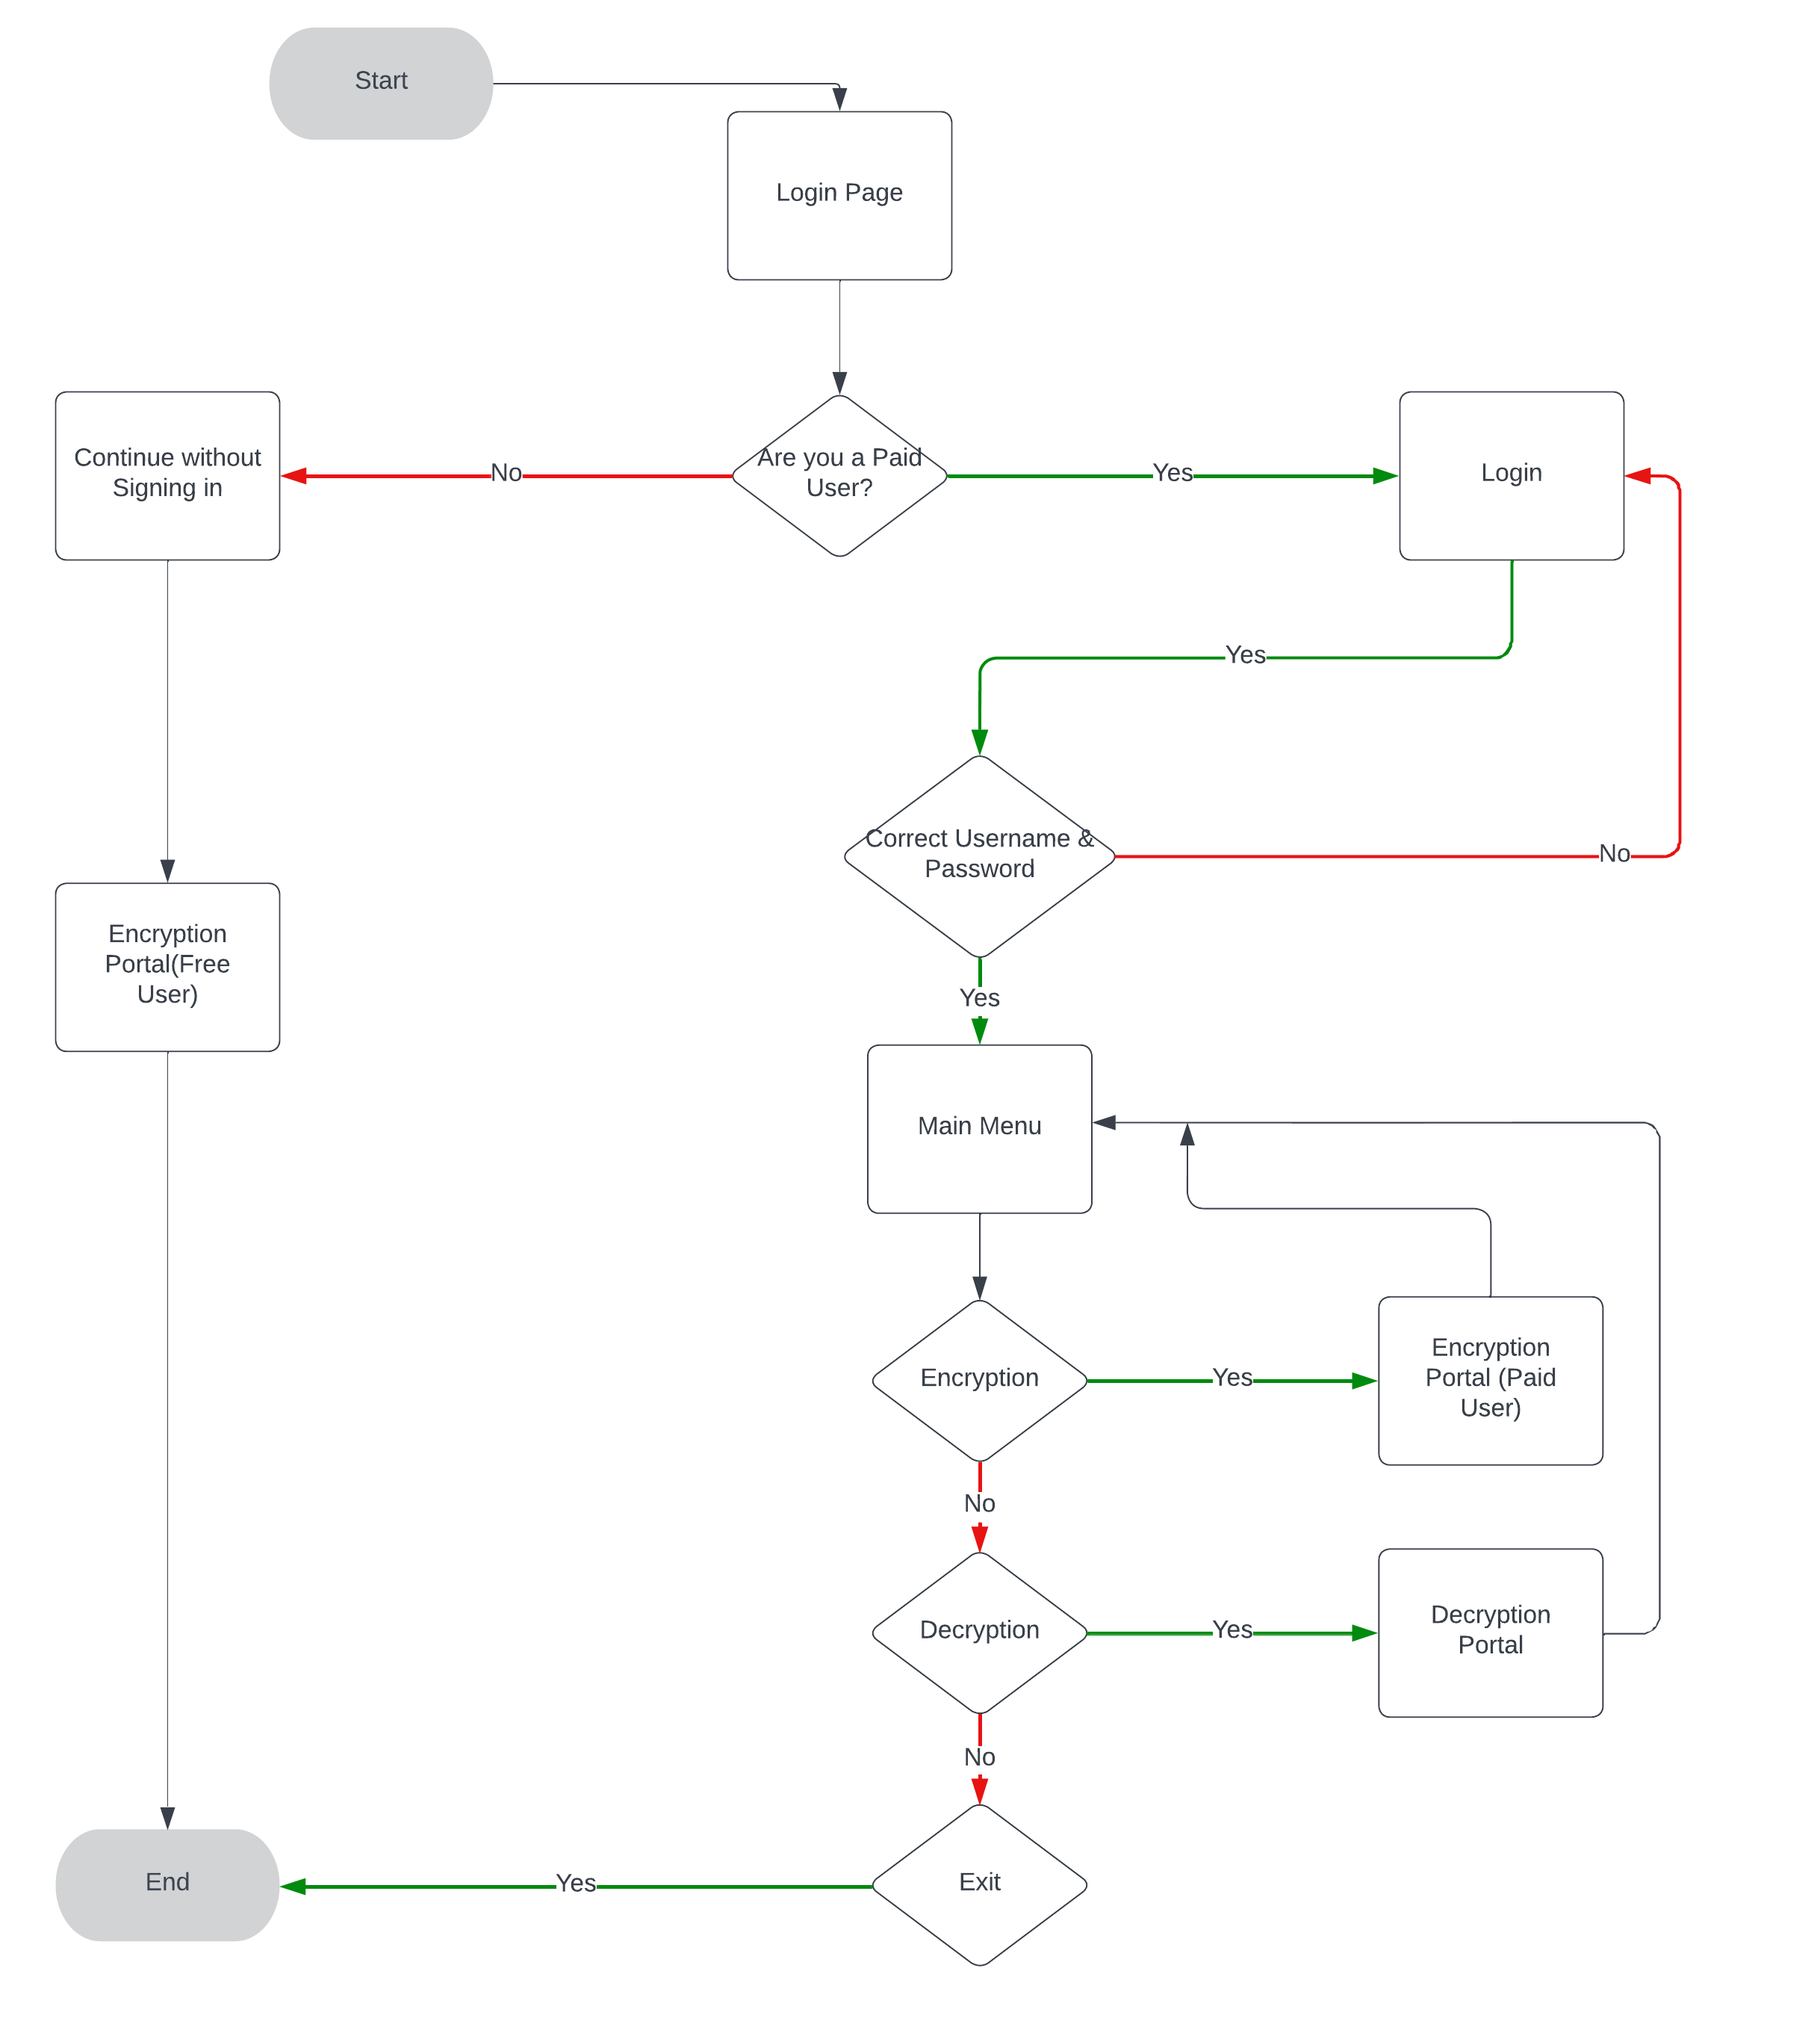

Testing Phase of Console Application

Testing Encryption Using File Handling
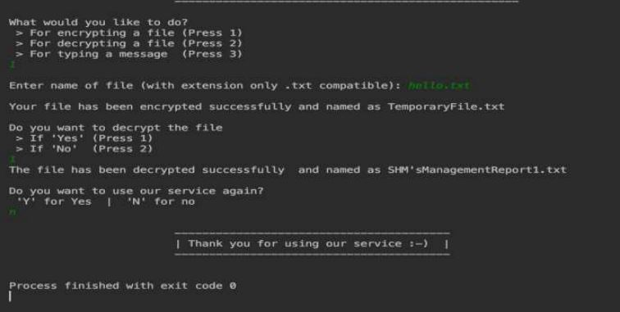
Console Layout
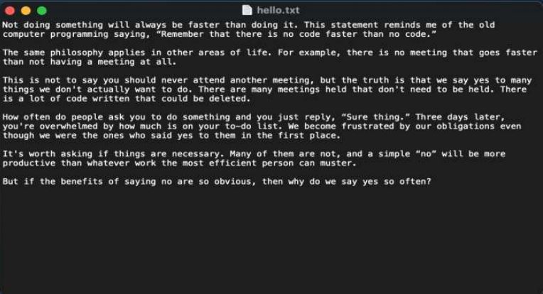
Input File (Plain Text)

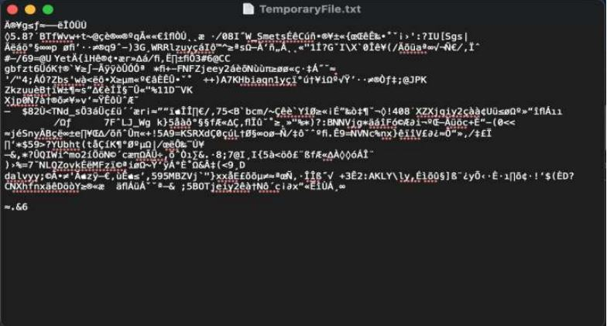
Encrypted File (Cyphered text)

Testing Decryption Using File Handling
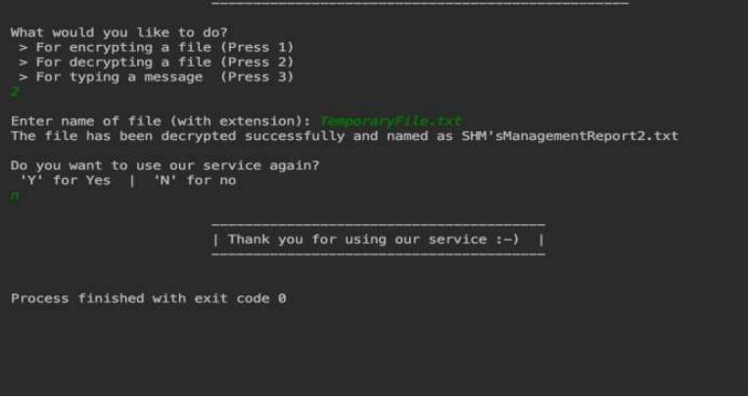
Console Layout

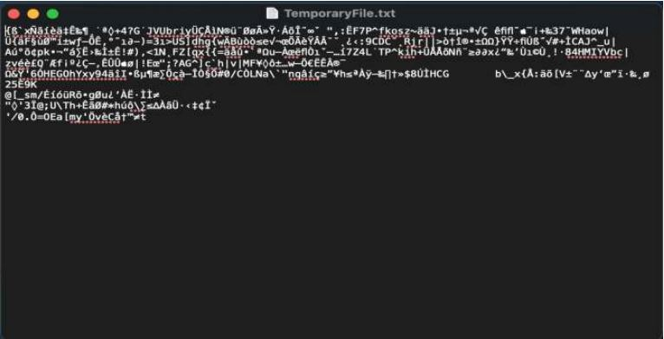
Input File (Encrypted)
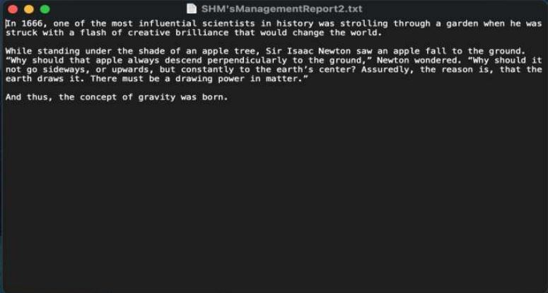
Output File (Decrypted)

String Message Encryption & Decryption.
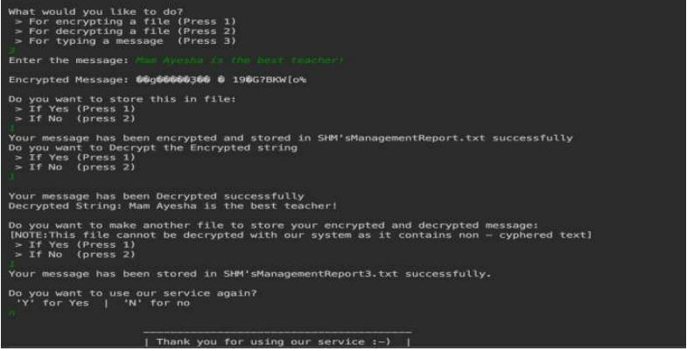
Console Layout
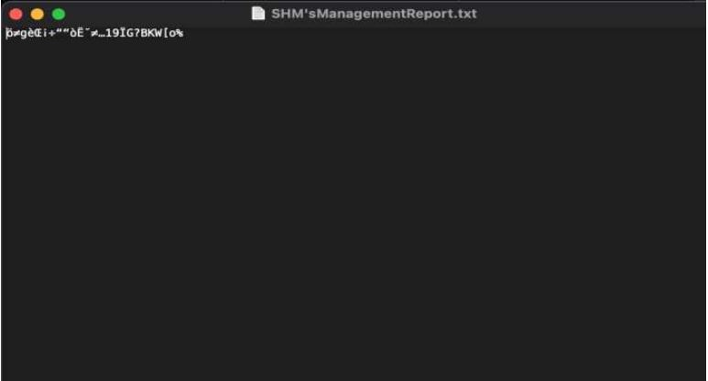
A File of the Encrypted Message
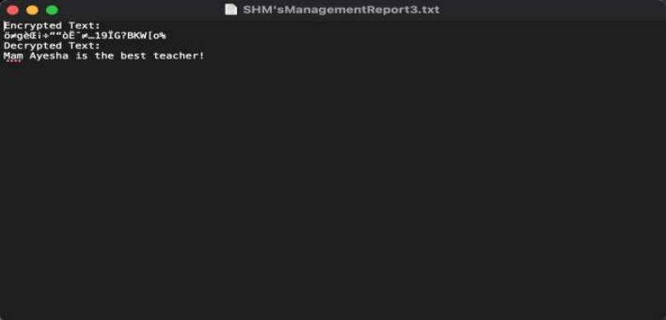
A File of Both Encrypted and Decrypted Message
During the Testing Phase Our Program Was working Exceptionally. We’ve had no issues in Making a console-based application. Now taking this to the next level by implementing GUI.

Program Functionality
The Project consists of 3 Main Functions which include the following:
1- File Encrypting using File Handling.
2- File Decryption using File Handling.
3- Message Encrypting which is entered by the user.
1- File Encryption:
In this the user will place his file in the Repository of the function and then he will enter the file name including the extension in the console.
Example - whatsappMessages.txt
As the User Enters the file name, the File Will be Encrypted and be placed in the same repository and will not be overwritten so the user will still have excess to the original file.
2- File Decryption:
In this the User will Again Place his File in the Repository of the function and Enter the File name in the console that he wants to be Decrypted.
Example - whatsappMessages.txt
As the user Enters the file name in the console the file will be Decrypted and will be user Readable once again.

3- Message Encrypting:
In this the User will Enter the Text in the Console Itself and He will be asked if he wants to store the Encrypted Message in a File or Not, If the user chooses to store it in a file, the Encrypted Text will be stored in: SHM’sManagementReport.txt
If the User Selects Not to store in the File, the Encrypted text will be displayed on the console and then the user will be asked if he wants to re-run the whole program again.
The User will be given another prompt if After choosing Yes is that if he wants to store both, his Encrypted and Decrypted Text in Another file in the Same Repository. The Text will store in: SHM’sManagementReport3.txt

Designing the GUI Algorithm
Our encryption algorithm increments a different value in each character in the user-selected file, resulting in a highly secure encrypted file. Any malicious attacker will be unable to decipher the encoded message because our algorithm follows no pattern.

Encryption
bool EncryptionOfFile(string givenFile)
{

tempFile.open("EncryptedFile.txt", ios::out);

int EncryptKey = 50;
char character1;

for (int i = 0; i < givenFile.size(); i++) {

if (givenFile[i] != '\0') {
givenFile[i] += EncryptKey;
tempFile << givenFile[i];
EncryptKey += 7;
}

}

tempFile.close();

return true;
}

Decryption
bool decryptionOfFile(string givenFile)
{

tempFile.open("DecryptedFile.txt", ios::out);

int DecryptKey = 50;
char character1;

for (int i = 0; i < givenFile.size(); i++) {

if (givenFile[i] != '\0') {

givenFile[i] -= DecryptKey;
tempFile << givenFile[i];
DecryptKey += 7;
}
}

tempFile.close();

return true;
}

GUI
The Output of the Code Consists of Two Different Outputs Which is pre-described in the Program itself. This Also Contains Error Checks That we’ve kept for each output.

Sign In Form
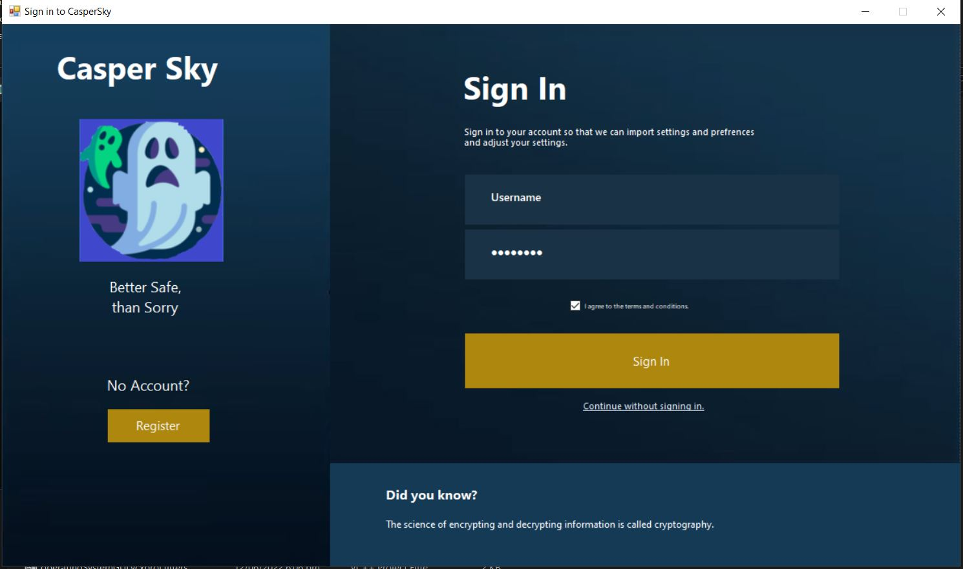
Main Sign in Form.
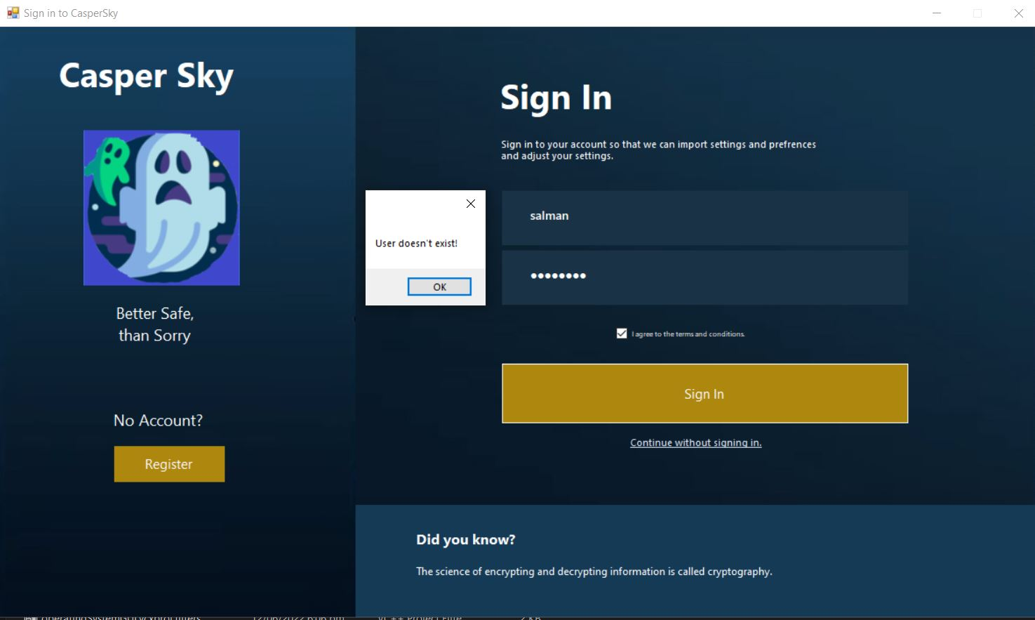
2Error is Shown as there is no User Salman.

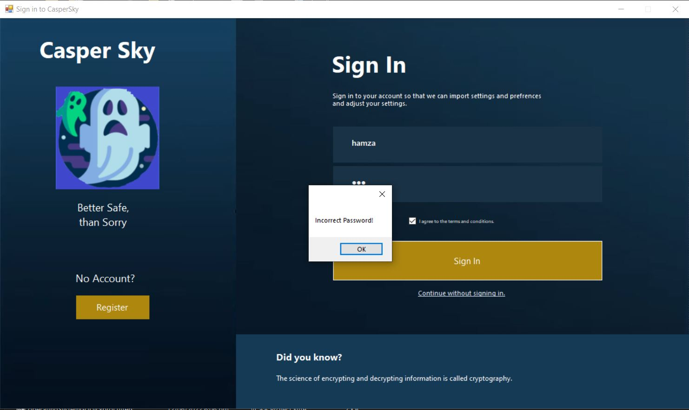
User hamza Exists but the password is incorrect.

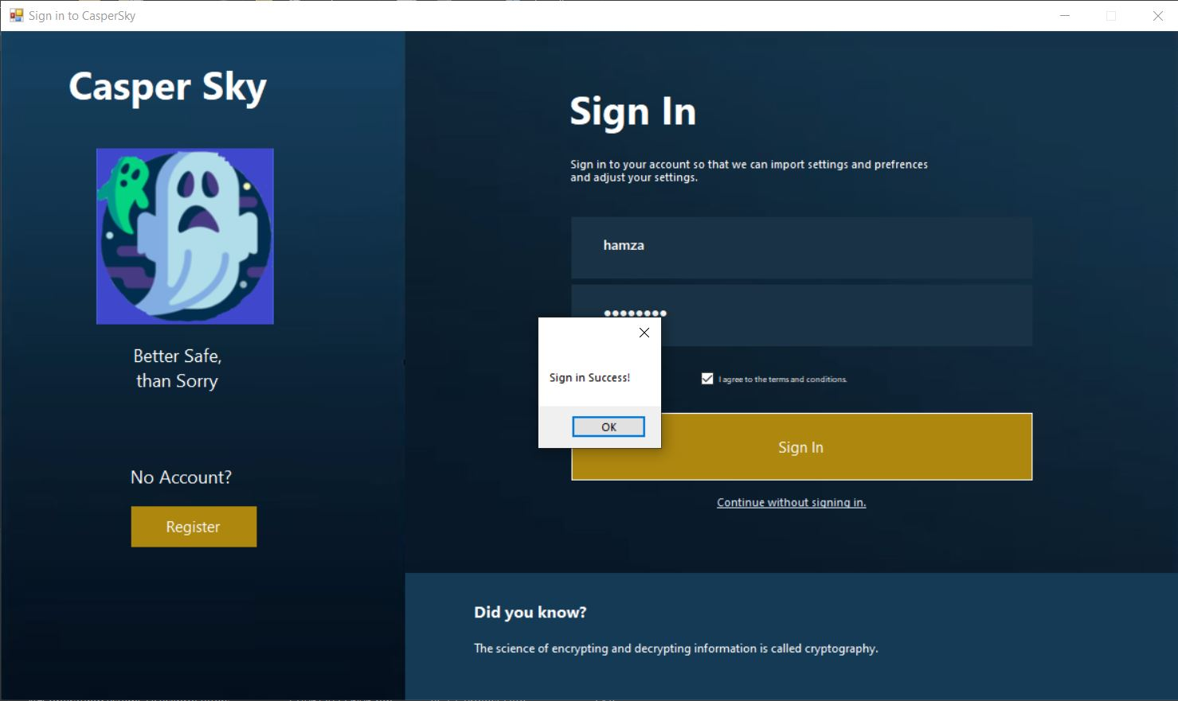
Sign in Success Pop-up since the Username and Password Match.

Main Menu
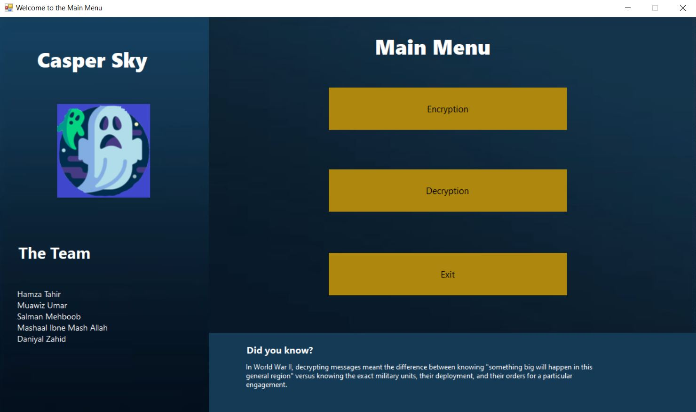
Interactive Main Menu to Help you easily Navigate Between Encryption & Decryption. Exit Button Added to close the application.

Encryption (Free User)
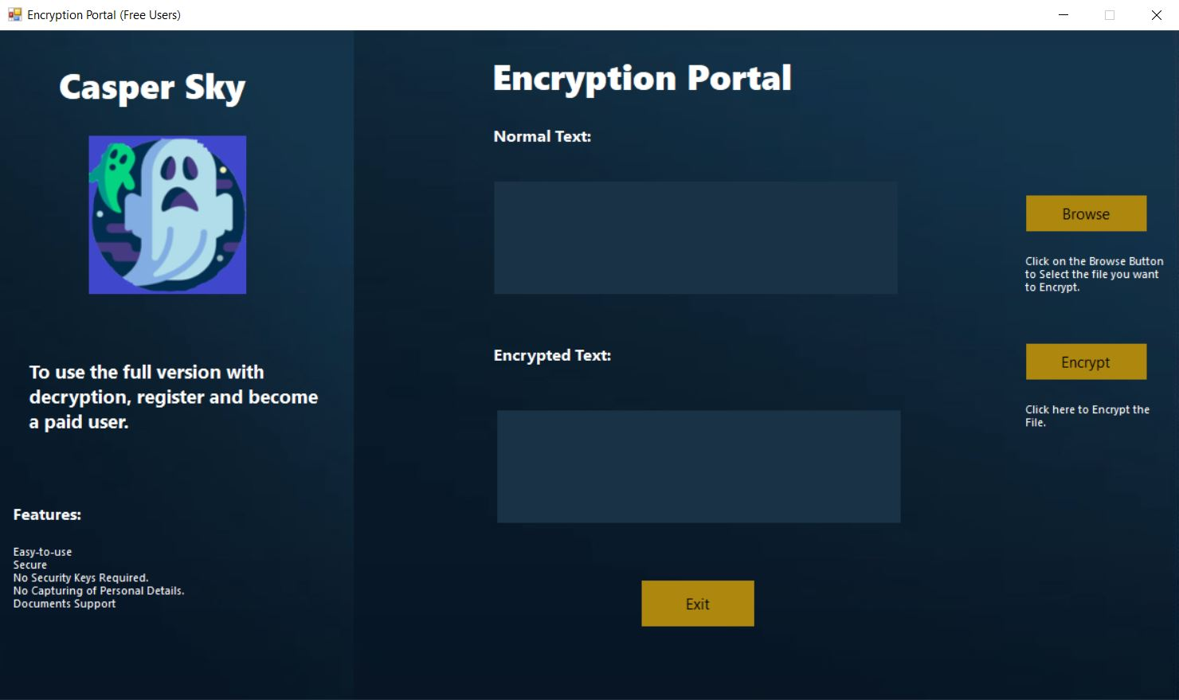
Main form for the Encryption Portal for free users who can directly access this page by clicking on continuing without signing in.

Encryption
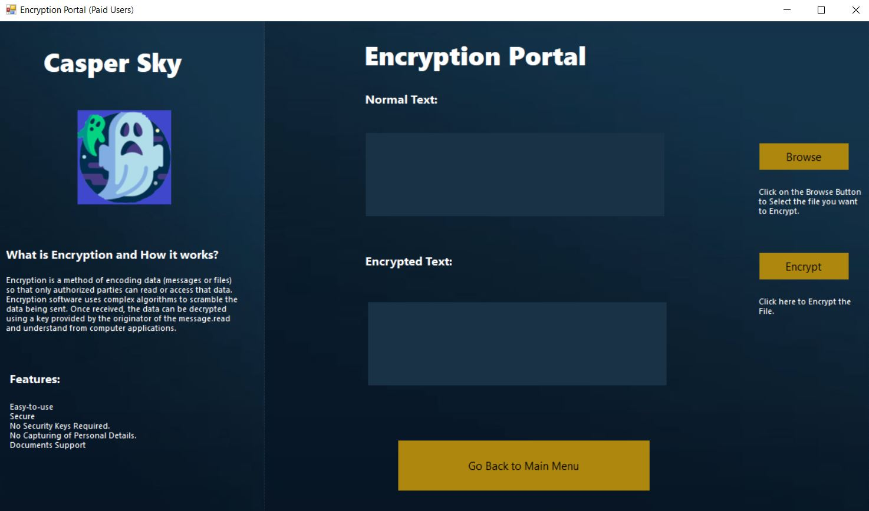
Main form for Encryption.

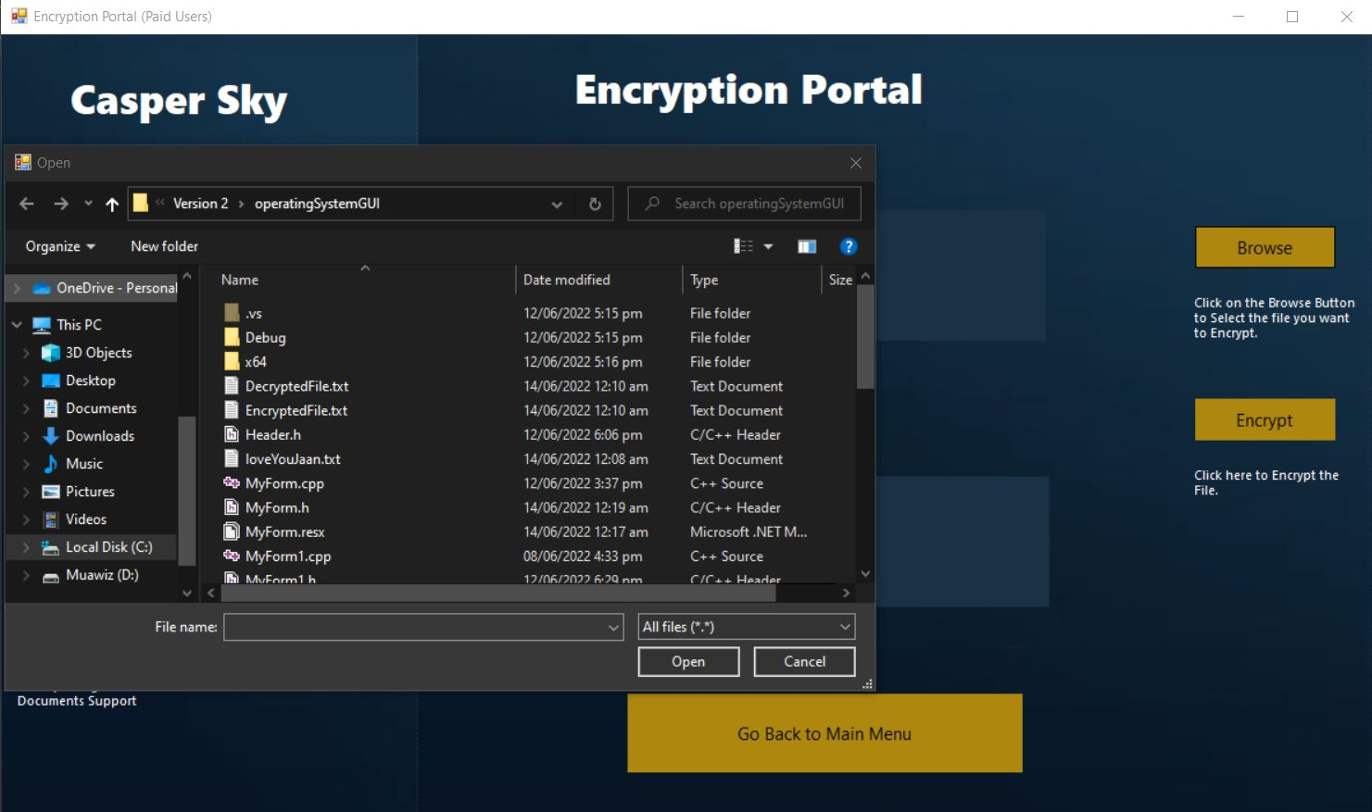
As user clicks on the Browse Button, he gets to access his directory, from there he selects the file.

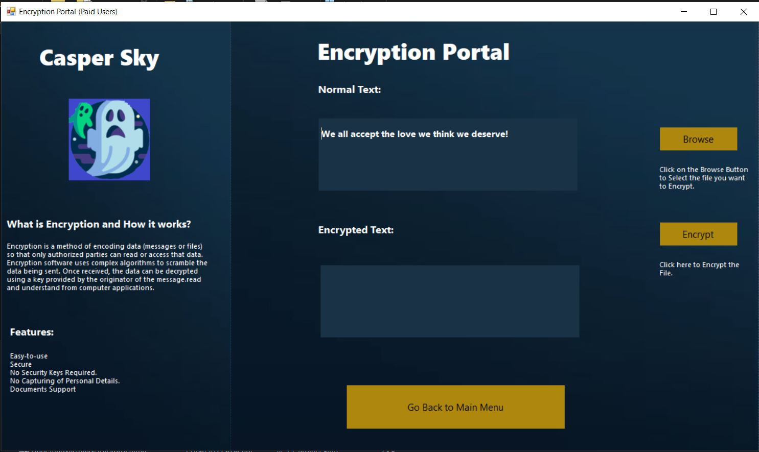
As the user selects the file the text is automatically copied and shown to the user.

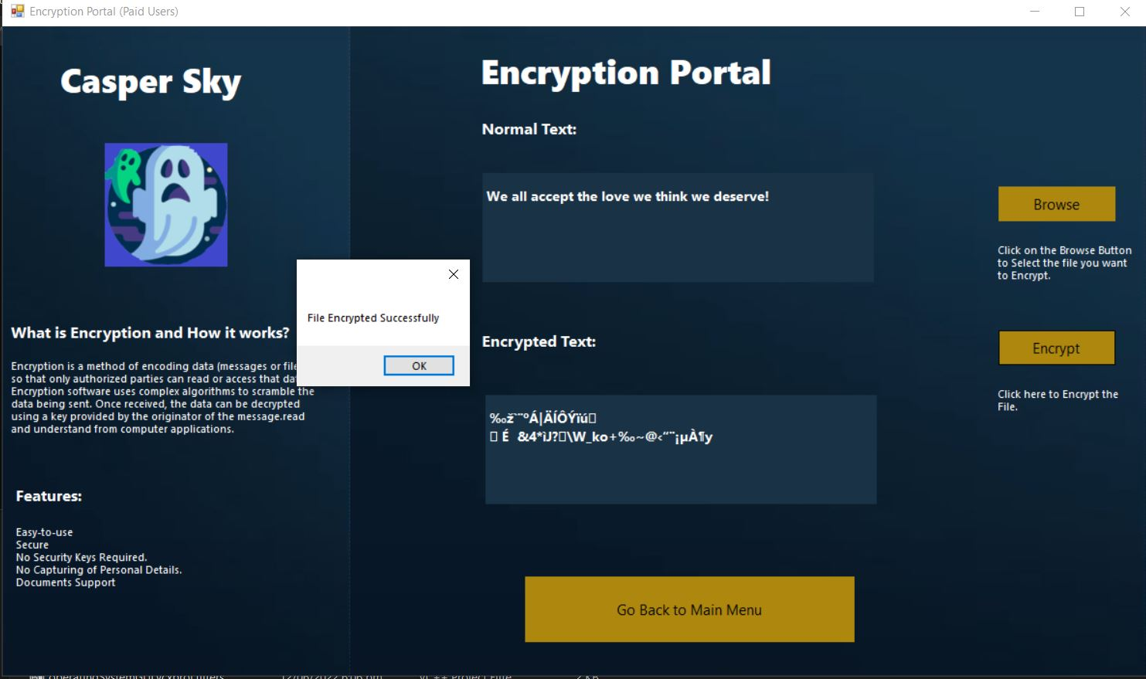
Here we click on Encrypt and as we’re done a Pop up is shown and encrypted text is Displayed on the Encrypted Text Box.

Decryption
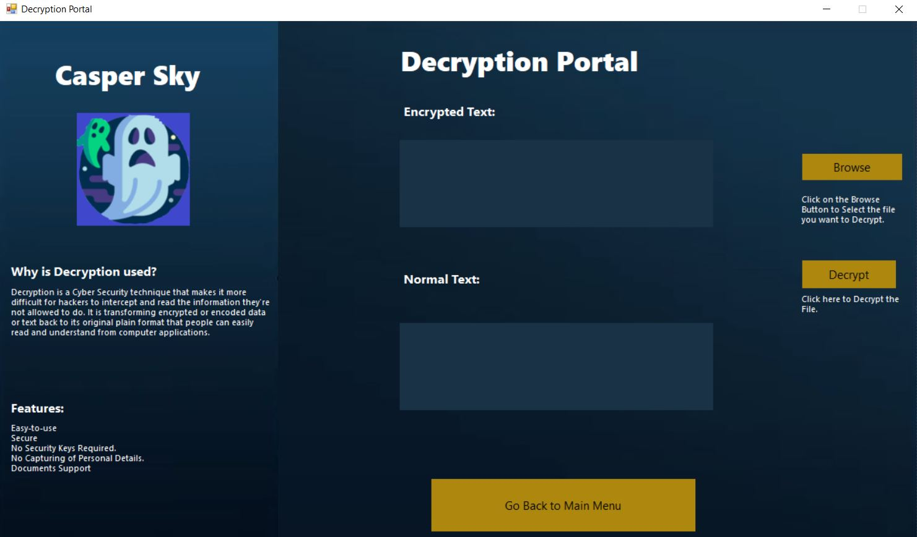
Main Decryption form displaying the contents.

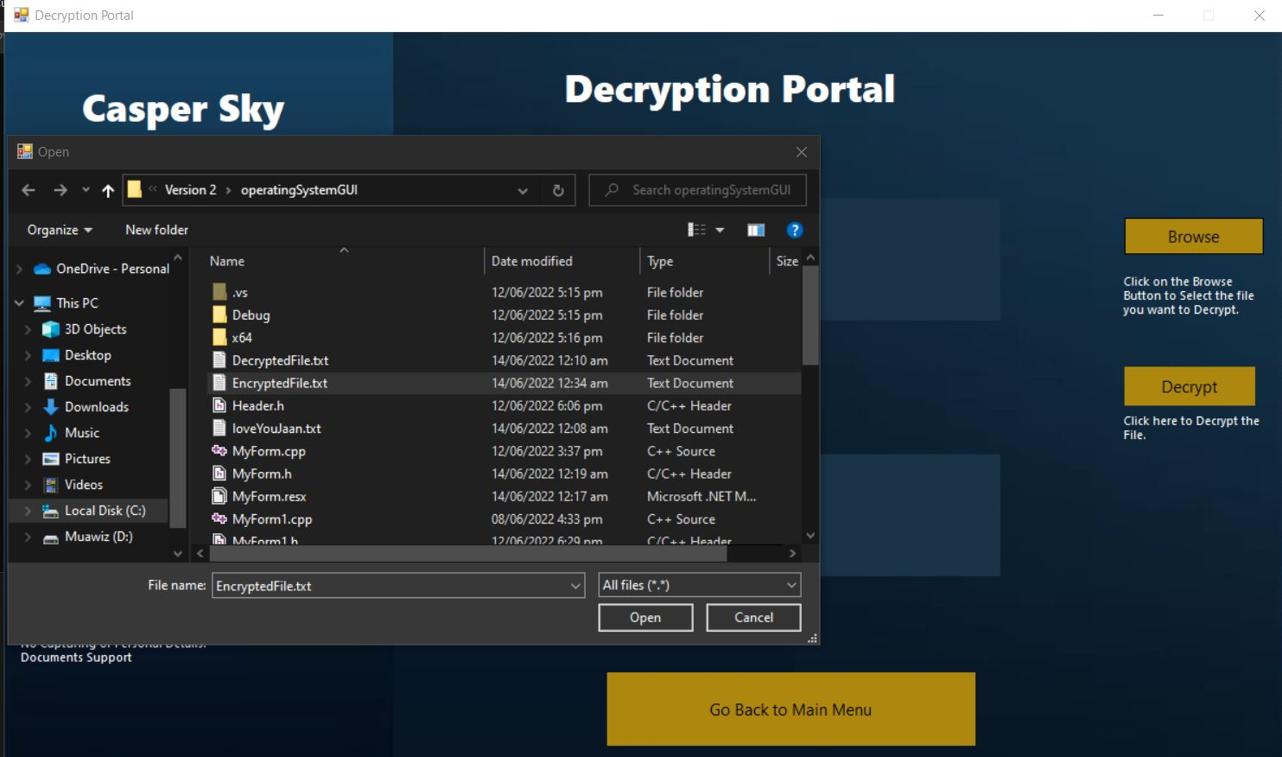
Here we’re selecting the EncryptedFile.txt which is already made. As the user has encrypted the text before.

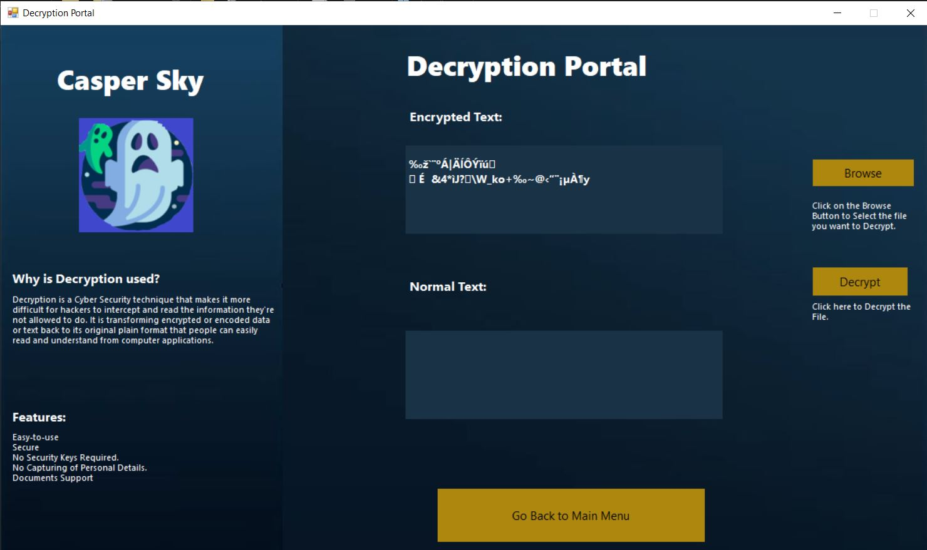
The text from EncryptedFile.txt is displayed on the Encrypted Text Box & displays the content of the file.

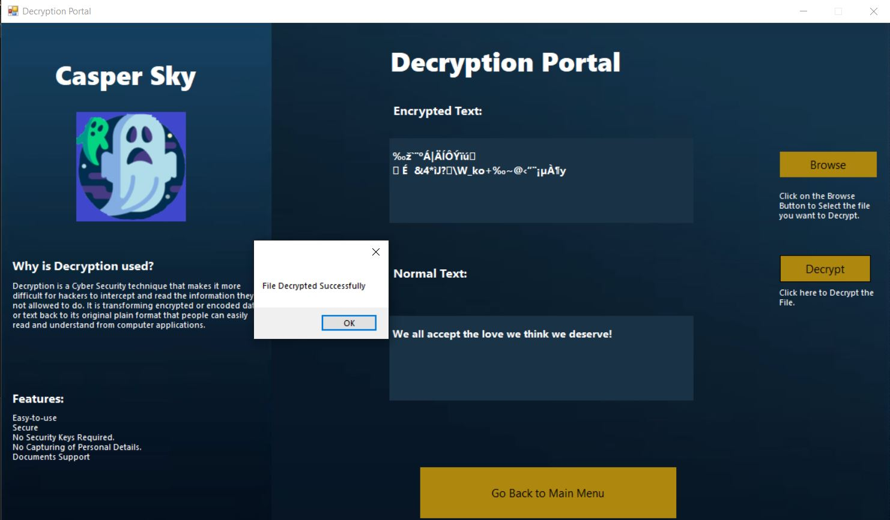
By Clicking on Decrypt our text is decrypted back to it’s Original Form and Saved in a file, DecryptedFile.txt

Limitations
Another one of its limitations is that we didn’t use Database, Integrating the use of Database could’ve been used for the Sign-Up button. But since we were not taught this course, we had no idea on how to apply it.
We used Hash tables in our code but later removed it because it doesn’t store the Usernames & Passwords in the program as the application is closed all prior data for the id-password is gone.

Conclusion & Future Work
At last, we made sure to main a friendly user experience for our customer, so program is as versatile as possible; being able to adapt to many different functionalities and change as per our future needs.
We are looking forward to implementing databases concept for our program for easy storing and accessing of user data without any threat of having data theft and lost.

